4 Methods for Extracting DNA from FFPE Tissue Samples
Posted on Tue, Sep 23, 2014
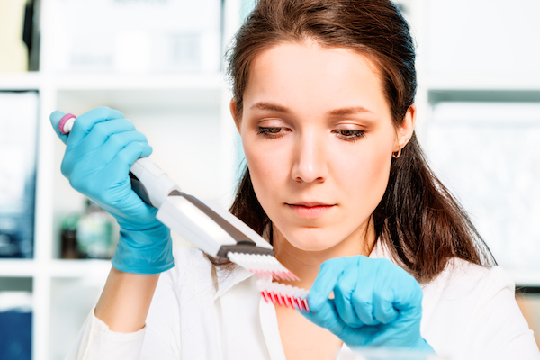Tissues stored for long time periods are typically fixed with formalin to preserve the tissue’s protein structure and then embedded in paraffin wax so that the tissue can be readily prepared in thin slices. This technique, known as formalin-fixed paraffin-embedded (FFPE), has been invaluable for providing well-annotated biospecimens for large-scale drug discovery and biotech research. This is because, for many research protocols, there is often a lack of adequate numbers of fresh tissue samples for projects such as cancer biomarker research.
Until recently, however, it was thought that FFPE tissues were not a valid source for studies involving nucleic acids, such as DNA and RNA. This is due to the fact that the formalin fixing process causes DNA-tissue protein cross-links, which can limit amplification and fragment nucleic acids. Fortunately, recent advances in DNA extraction and recovery techniques now assist researchers seeking to gather important molecular and genetic information from FFPE tissue specimens.
There are a variety of methods used to obtain DNA from FFPE samples; here we summarize four of the more common methods:

1. Proteinase K digestion
Many studies have looked at DNA extraction procedures, and there seems to be nearly universal agreement that one of the most important steps in DNA extraction from FFPE tissues is the protein digestion process. This step enables researchers to obtain DNA that is of sufficiently good quality for subsequent purification. Proteinase K is the most commonly chosen protease. A recent study comparing extraction protocols "found statistically significant evidence that longer digestion periods produce greater amounts and higher concentrations of DNA."

2. Heat-treatment
This method is one of the fastest and easiest ways to extract DNA for PCR amplification. Heat is applied to FFPE specimens to melt the paraffin, lyse cells and decrease cross-linking. Heat incubation typically occurs at 56°C. According to one of the companies providing fast DNA heat-extraction kits, the extracted DNA “has been used successfully in standard and fast end-point PCR, random amplification of polymorphic DNA PCR, mitochondrial PCR, and real-time PCR. The resulting amplicons can be used for single-nucleotide polymorphism (SNP) detection or DNA sequencing.”

3. Silica membrane-based column extraction
A widely utilized method for purification of DNA from FFPE tissues, this technique involves lysis of specimens to release DNA and overcome cross-links caused by formalin fixation. Then, spin columns purify small volumes of DNA. In one study comparing DNA extraction methods, authors concluded that "for amplification of longer DNA fragments - up to 600 bp" the commercial kit utilized "was most suitable."

4. Magnetic silica beads-based extraction
Following one commonly-used commercial method, tissue samples are lysed, homogenized and incubated. Then magnetic silica bead technology is used for DNA extraction. One study comparing extraction methods found that this technique, as well as the silica membrane-based column extraction method, performed best for real-time single nucleotide polymorphism (SNP) detection.
There are a variety of methods used to improve the purity, quality and yield of DNA from FFPE tissue specimens. The method you use for extracting DNA from such tissues should be selected based on your endpoint application. Whatever method you use, we stand ready to provide you with well-sourced, highly-annotated FFPE tissue specimens for your drug discovery and biomedical research.

